MODEL ENGINEERING COLLEGE, THRIKKAKARA

DEPARTMENT OF COMPUTER ENGINEERING

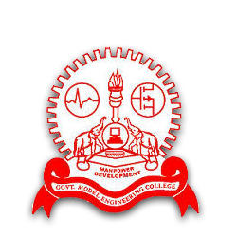

RECORD OF PRACTICAL WORKS

EST 102 PROGRAMMING IN C

CLASS: CS 2 B (2019 Ad.)

      Name of Student: ADITHYA A

Roll No: 03